**Crystal Reports Assignment 2**

**Due: See date in BB**

1. Create an Order List report using the report wizard and the Xtreme Bicycles database (xtreme.mdb). Use the Orders table and include the fields shown. There is one group field (customer id), use the table report style. You will have to adjust the report date field and modify the justification as shown. Add a report title to the report in Tahoma size 18, bold, and your name in Arial size 12(not bold). Move the sum for order amount as shown. Add the logo xtreme_logo.jpg . Filter the results so only orders delivered via UPS are included. Add your name beside the title.

**Bonus** : change the date format for the report date to DD-Mon-YYYY.

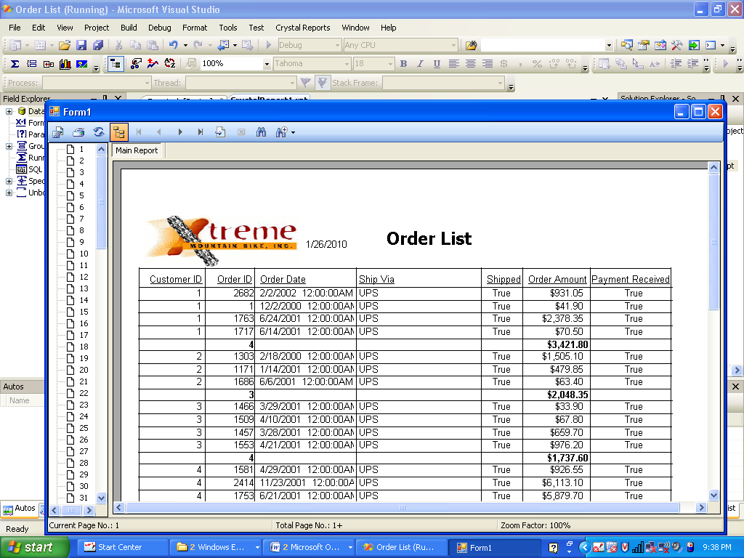

2. Modify the Product Vendor List report starting from the report in the folder ”Product Vendor List” on I: and adding items manually. Add a group by Supplier ID and count for the number of products in each group. Add a sum for the price field for the group and also in the grand total. Add the title and change the font for the title to size 14. Add the logo as in Q1. Add your name beside the title.

